**ASSIGNMENT – 3**

|  |  |
| --- | --- |
| Assignment Date | 13 November 2022 |
| Student Name | S.EBINESAR WASHINGTON |
| Team ID | PNT2022TMID52536 |
| Maximum Marks | 2 Marks |

1. Create a Bucket in IBM object storage.

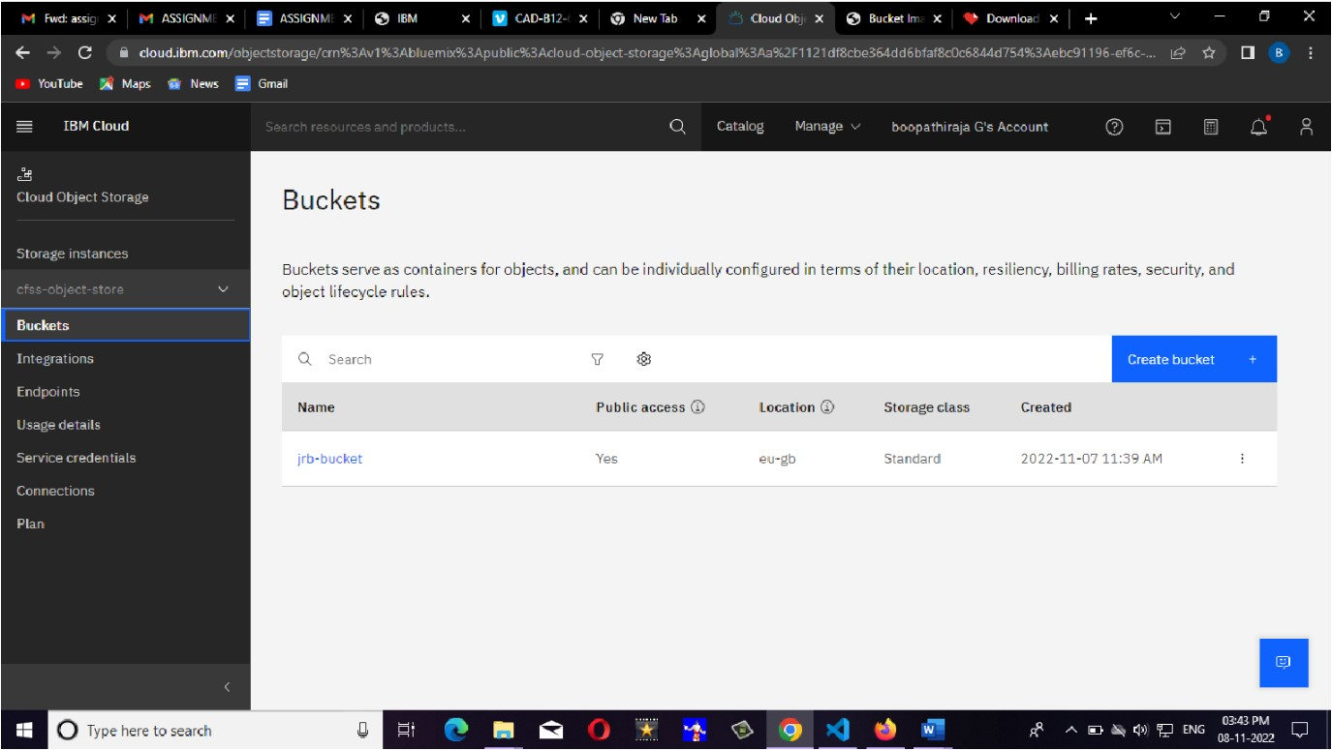

1. Upload an 5 Images to IBM object storage and make it public. Write HTML code to displaying all the 5 Images.

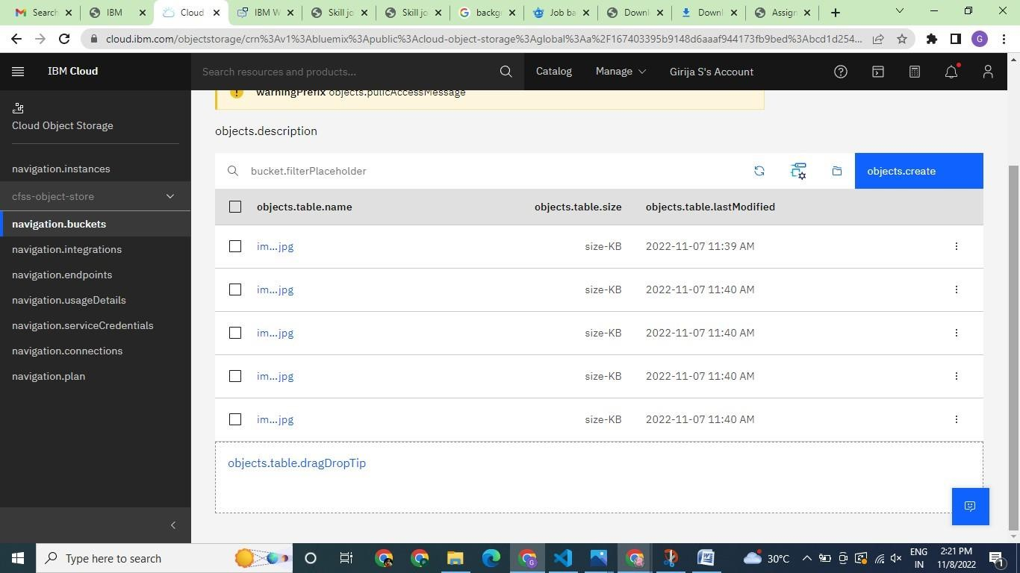

1. Upload a CSS page to the object storage and use the same page in your HTML code.

CSS code

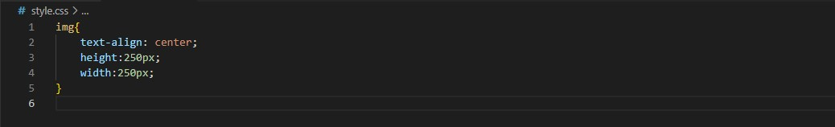

HTML code

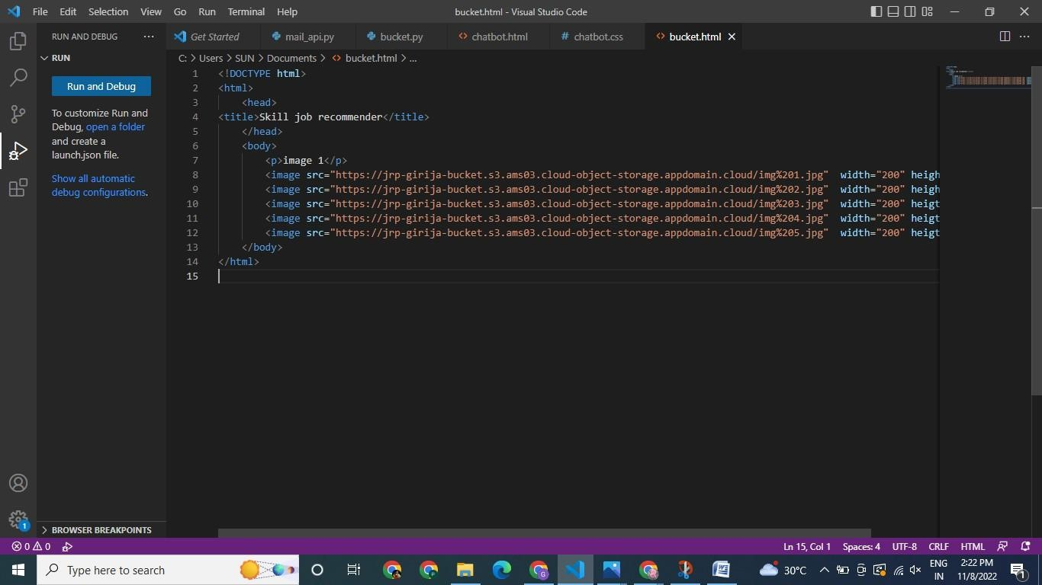

Output

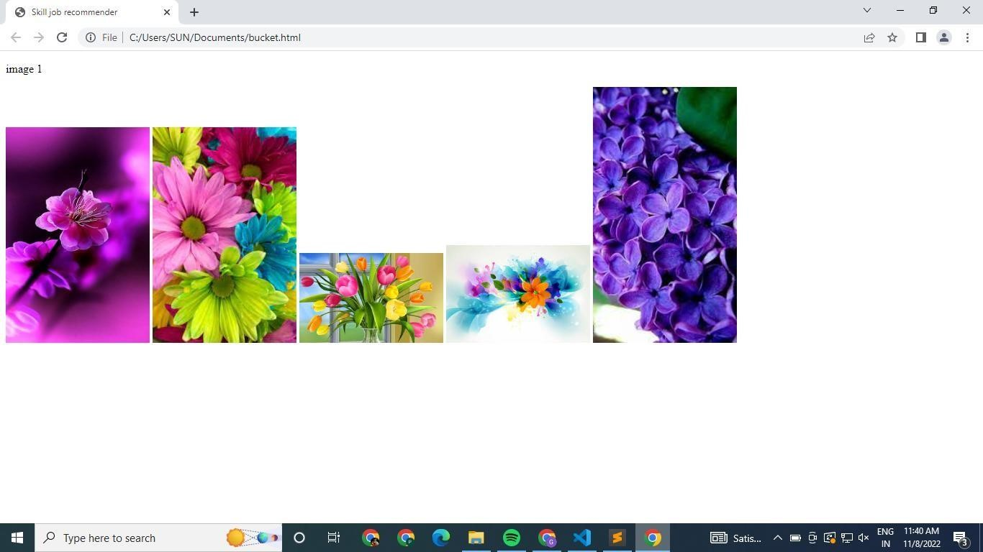

1. Design a Chatbot using IBM Watson assistant for Smart Fashion Recommender.

Code:

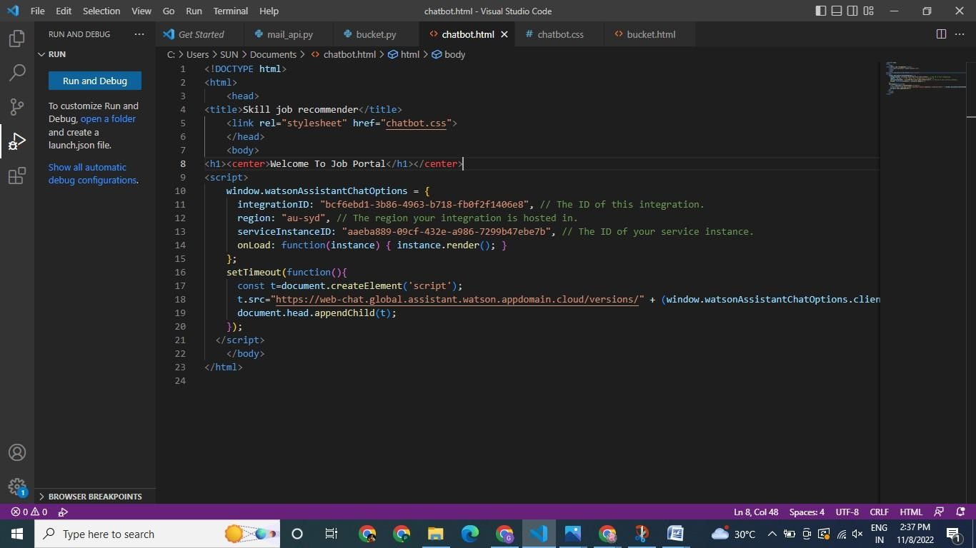

CSS code

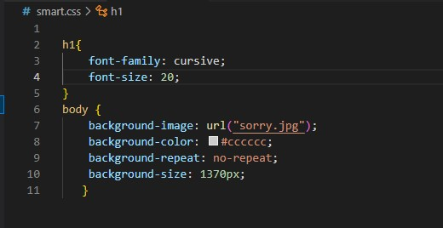

Waston Assistant Chatbot Output

